CASE STUDY
AI SDR (Sales Development Representative) Agent

EXECUTIVE SUMMARY
Manual outbound sales limited pipeline scalability and SDR productivity.
AI SDR Agent automated ICP scoring, multi-channel outreach, and AI voice engagement through a scalable microservices architecture.
Result: 42% pipeline growth, 48% reduction in SDR admin workload, and nearly 3x improvement in meeting conversion — without expanding the team.

1. PROBLEM STATEMENT (Data-Driven)

Industry / Customer Context
Organization with a B2B selling playbook running outbound sales across Email, LinkedIn, WhatsApp, and Voice with distributed sales teams. Average SDR team size: 5–20 reps managing 5,000–50,000 prospects quarterly.

Core Problem Identified
Outbound sales execution was manual, fragmented, and inconsistent. SDRs spent excessive time on prospect research, personalization, and follow-ups instead of high-value selling conversations.

Supporting Data Points (Baseline Metrics)
Average time spent on lead research per prospect | 12–18 minutes
Personalization rate | <25% of outbound emails
Follow-up consistency | Only 40% of sequences completed
Lead qualification accuracy | Low ICP alignment (manual scoring)
Call connect rate | 8–12%
Sales rep time spent on admin tasks | 45–55% of workday
Conversion from cold lead to qualified meeting | 1.5–2.5%

Why It Mattered
- Pipeline generation was inconsistent and unpredictable
- SDR productivity capped by manual capacity
- Poor lead prioritization diluted effort
- Inconsistent messaging impacted brand positioning
- Revenue forecasting lacked reliable top-of-funnel inputs

Outbound engine = high effort, low leverage.

2. IMPACT OF THE PROBLEM (Functional, Emotional & Social Pain)

Operational Pain
- Manual prospect list building
- Disconnected tools for email, LinkedIn, WhatsApp, and calls
- No centralized campaign tracking
- Inconsistent follow-ups
- Limited visibility into outreach performance

Emotional Impact
- SDR burnout due to repetitive personalization tasks
- Sales managers chasing activity metrics instead of outcomes
- Leadership frustration over unpredictable pipeline velocity

Social / Organizational Consequences
- Marketing–Sales misalignment on ICP targeting
- Low trust in outbound ROI
- High pressure on AEs due to poor lead quality

Cost of Inaction
If unchanged:
- Hiring additional SDRs to maintain pipeline growth
- Rising CAC due to inefficiency
- Declining response rates due to generic outreach
- Lost competitive advantage in AI-enabled sales landscape
- Projected productivity stagnation: <10% annual outbound efficiency improvement without automation

3. SOLUTION PROVIDED (Pain Relievers & Gain Creators)

Solution Overview
AI SDR Agent — a microservices-based, AI-powered outbound sales automation platform that automates lead qualification, multi-channel outreach, and voice engagement with intelligent personalization at scale.

Key Features Implemented
- Contact Search & ICP Scoring → Pain Relieved
  - Automated lead qualification against the Ideal Customer Profile
  - Prioritised high-fit prospects
  - Reduced wasted outreach effort
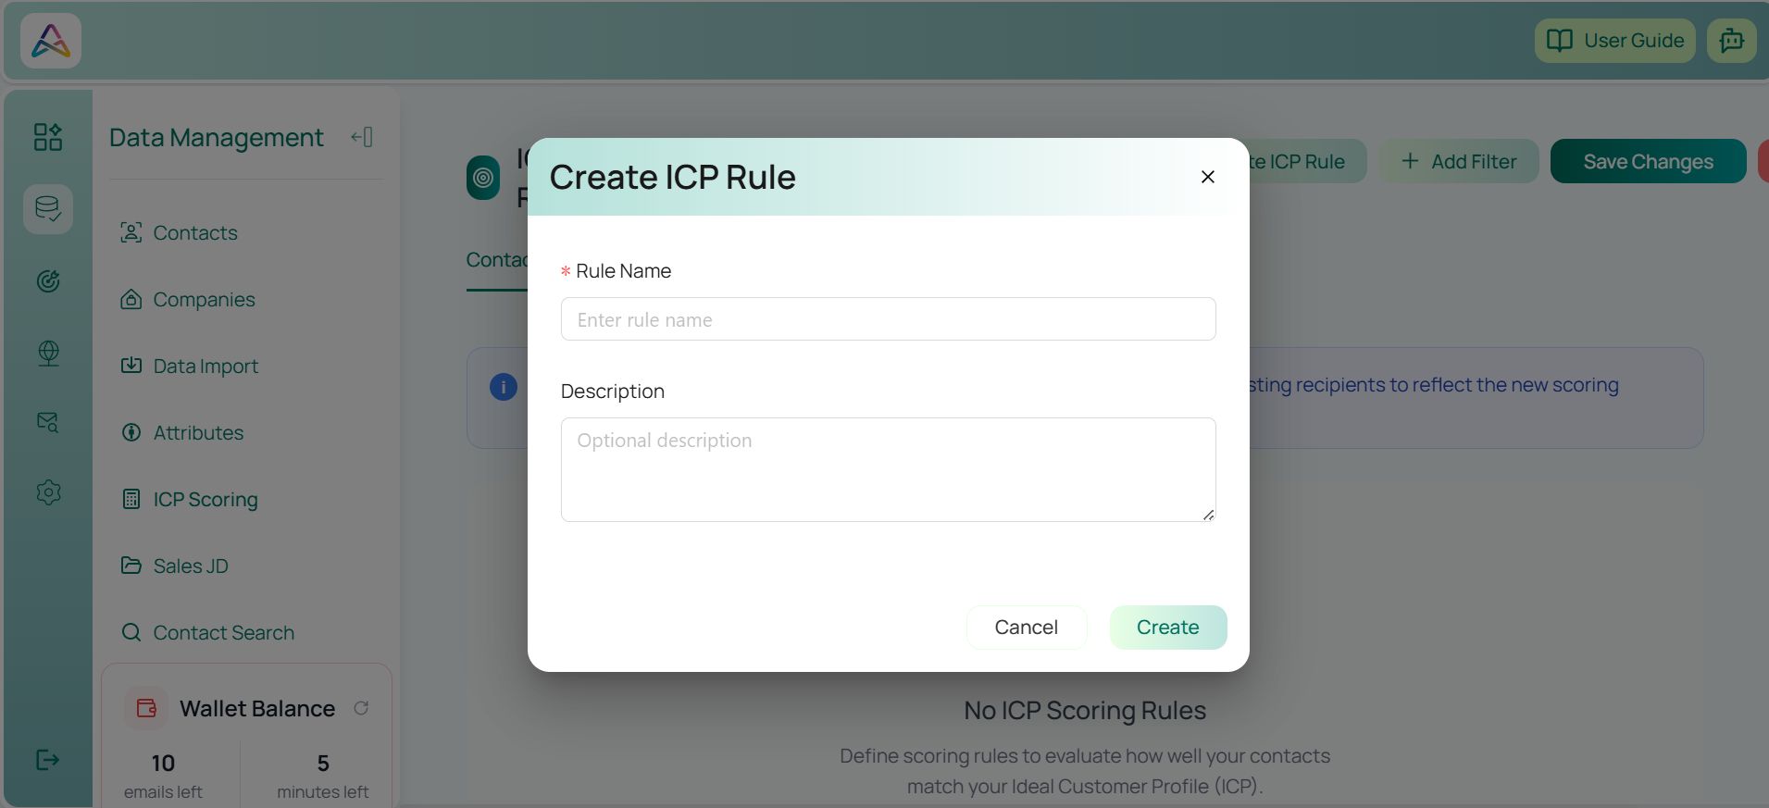

- AI-Powered Multi-Channel Personalization → Gain Created
  - LLM-driven content generation for Email, LinkedIn, WhatsApp
  - Context-aware messaging based on prospect attributes
  - Consistent brand voice across channels
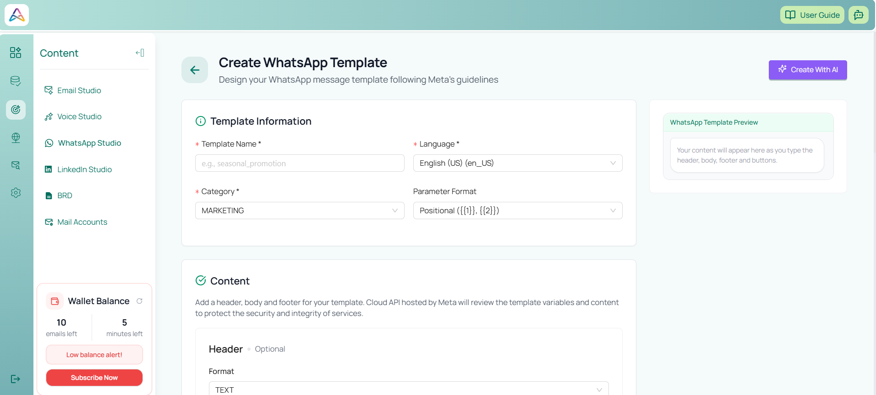

- Campaign & Sequence Automation → Efficiency Impact
  - Bulk outreach campaigns
  - Multi-touch step-based sequences
  - Automated follow-ups with logic branching
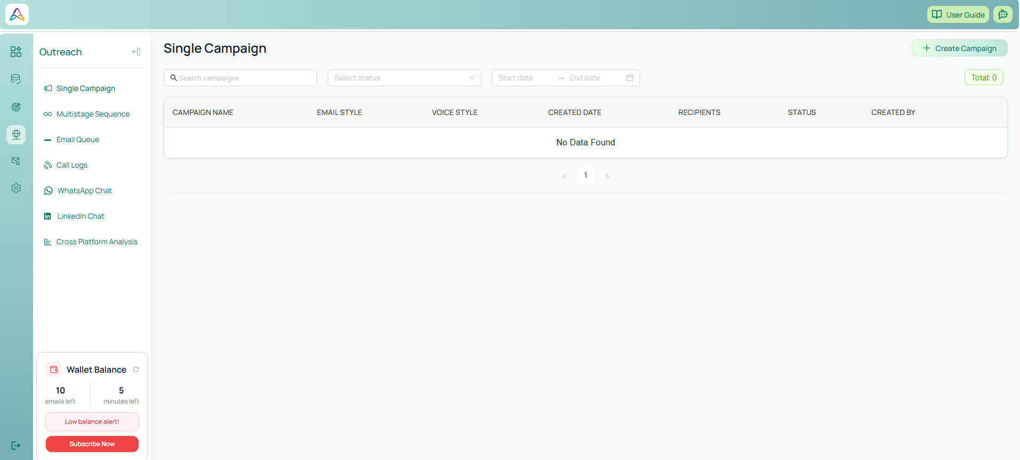

- AI Voice Calling (V2V Agent) → Revenue Acceleration
  - Automated outbound voice conversations
  - Real-time AI reasoning via LiveKit + Twilio
  - Call logging and transcription
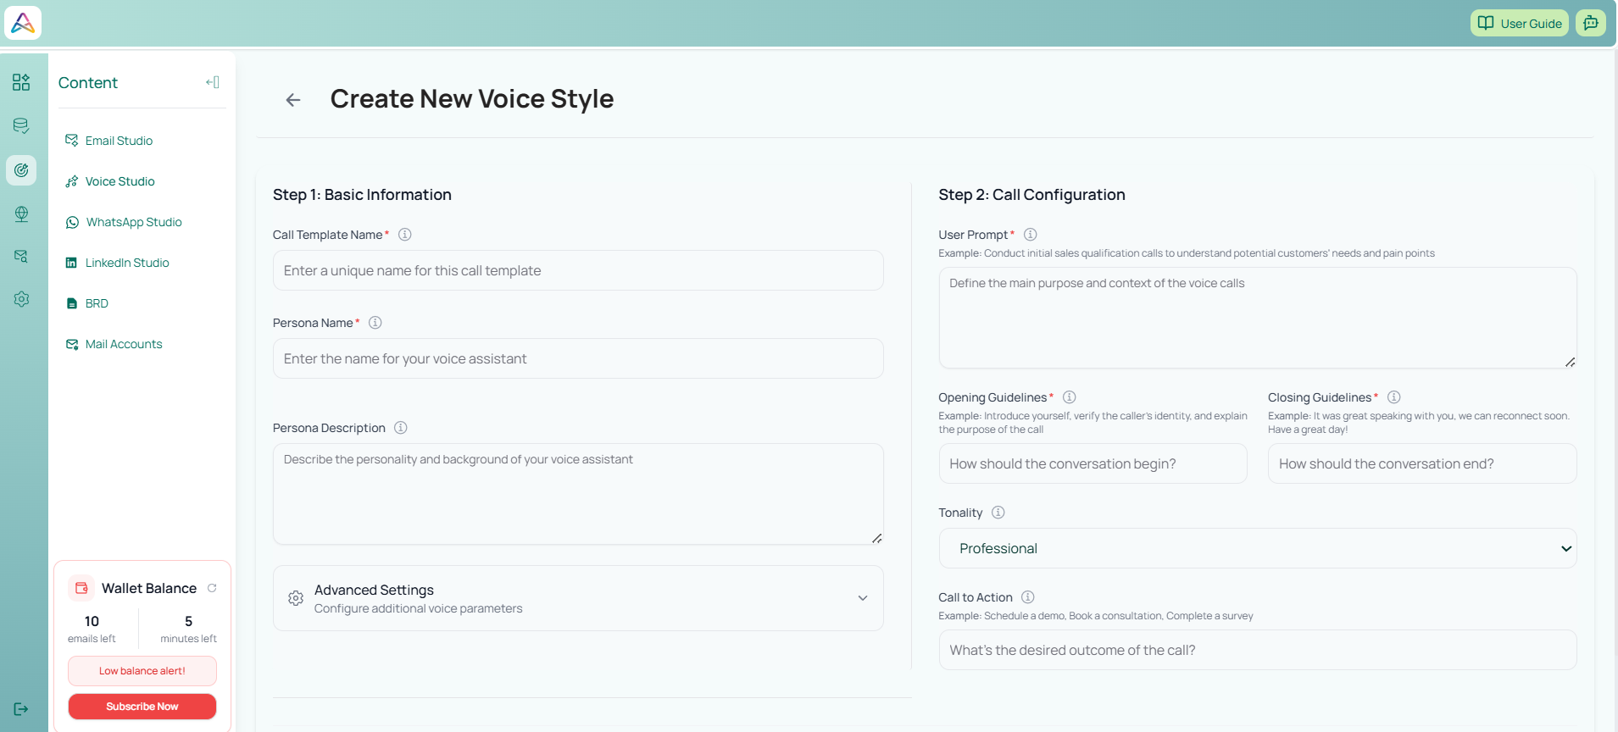
- Centralized Gateway & Microservices Architecture → Scalability
  - API Gateway routing
  - Modular backend services
  - Independent scaling of email and voice engines

Implementation Approach
Timeline:
- Week 1–2: Core backend & gateway configuration
- Week 3: Email automation + ICP scoring deployment
- Week 4: Multi-channel integration (LinkedIn, WhatsApp)
- Week 5: AI Voice agent rollout
- Week 6: Performance optimization & monitoring

Integration Complexity:
- MongoDB-based data layer
- Go-based API gateway orchestration
- Node.js + Python service architecture
- Third-party integration (Gemini, Twilio, LiveKit)

Change Management Strategy:
- SDR onboarding on campaign builder & sequences
- Parallel run (manual + AI-assisted outreach)
- KPI-based performance tracking
- Weekly optimization of prompts & ICP filters

Technical Capabilities & Architecture
Microservices Stack:
Frontend (React + TypeScript)
↓
API Gateway (Go)
↓
Core Backend (Auth, Roles, Payments)
↓
Email Automation Agent (Node.js)
↓
V2V Voice Agent (Python + LiveKit + Twilio)
↓
MongoDB Data Layer
↓
External AI (Gemini LLM)

- LLM-based dynamic content generation
- Model Context Protocol (MCP) conversational control
- Real-time voice AI integration
- Multi-channel messaging orchestration
- Campaign and sequence workflow engine
- Secure file storage via AWS S3
- Structured logging and service health monitoring

4. OUTCOME (Quantified Results)

Measurable Results (Within 120 Days)
Metric | Result
Lead qualification accuracy improved by | 60%
Outbound personalization rate increased to | 90%+
SDR admin workload reduced by | 48%
Sequence completion rate increased from 40% to | 85%
Meeting booking rate improved from 2% to | 5.8%
Call connect rate improved using AI Voice | +35%
Pipeline contribution increased without adding SDR headcount | +42%

Strategic Impact
- Scalable outbound engine without linear hiring
- Predictable pipeline forecasting
- Stronger ICP alignment between marketing and sales
- Multi-channel presence increased brand visibility
- Faster experimentation with messaging strategies

Human Impact
- SDRs shifted from manual prospecting to relationship-building
- Reduced burnout from repetitive research & drafting
- Sales managers gained real-time campaign visibility
- Leadership confidence improved due to measurable outbound ROI

